**2022**

**Team-Jasjot**

**Fenny Labs**

**10/9/2022**

**Market Segmentation Analysis**



**Market Segmentation**

1. Strategic and Tactical Marketing
2. Definition of Market Segmentation
3. The Benefit of Market segmentation
4. The cost of Market segmentation
5. **Strategic and Tactical Marketing**

* The purpose of marketing is to match the genuine needs and desires of consumers with the offers of suppliers particularly suited to satisfy those needs and desires. This matching process benefits consumers and suppliers, and drives an organization's marketing planning process.
* Marketing planning is a logical sequence and a series of activities leading to the setting of marketing objectives and the formulation of plans to achieving them.
* **A marketing plan consists of two components:**
* Strategic Marketing Plan
* Tactical Marketing Plan
* **Strategic Marketing Plan**
  + The strategic plan outlines the long-term direction of an organization, but does not provide much detail on short-term marketing action required to move in this long-term direction.
  + The strategic marketing plan states where the organization wants to go and why.
* **Tactical Marketing Plan**
  + The tactical marketing plan does the opposite.
  + It translates the long-term strategic plan into detailed instructions for short-term marketing action.
  + The tactical marketing plan contains instructions on what needs to be done to get there.

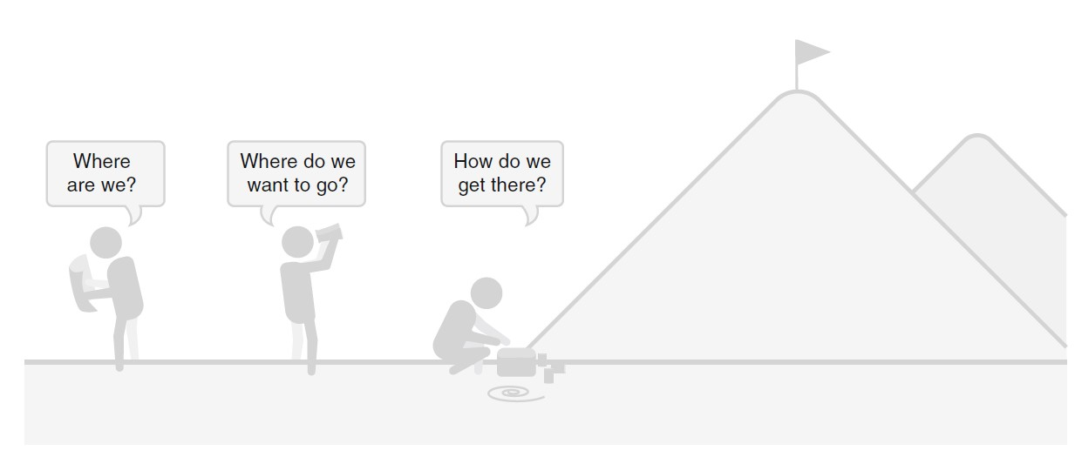

**Fig. 1.1** Strategic and tactical marketing planning. (Modified from McDonald and Morris 1987)

* **Examples: -**
  + The Strategic and tactical marketing planning is much like going on a hiking expedition.
  + The strategic marketing plan is the choice of mountain.
  + The tactical marketing plan is which time of day to depart, and how much food and drink to pack.
  + All these tactical decisions are important to ensure a safe expedition, but they depend entirely on the strategic decision of which mountain to climb.
  + Preparations for the mountain climbing expedition are similar to the development of an organizational marketing plan.
  + The strategic marketing plan typically identifies consumer needs and desires, strengths and weaknesses internal to the organization.
* **The Strategic and tactical marketing planning: -**
  + A **SWOT** analysis explicitly states an organization's strengths (S), weaknesses (W), opportunities (O), and threats (T).
  + As such, the SWOT analysis outlines **one side of the matching process**: what the supplier is particularly suitable to offer consumers.
  + **The other side of the matching process** – consumer needs and desires – is typically investigated using market research.
* The tactical marketing plan depends entirely on the strategic marketing plan, but the strategic marketing plan does not depend on the tactical marketing plan.
* Strategic marketing is the foundation of organisational success.
* **As part of the strategic marketing planning process two key decisions have to be made: -**
  1. **Which consumers to focus on**.
     + Segmentation and targeting
  2. **Which image of the organization to create in the market.**
     + Positioning
* **Tactical marketing planning usually covers four areas: -**
  1. **The development and modification of the product** 
     + In the view of needs and desires of the target segment (Product).
  2. **The determination of the price**
     + in view of cost, competition, and the willingness to pay of the target segment (Price).
  3. **The selection of the most suitable distribution channels** 
     + To reach the target segment (Place).
  4. **The communication and promotion of the offer** 
     + In a way that is most appealing to the target segment (Promotion).
* **Most Important Outcomes**
  1. The combination of good strategic marketing and good tactical marketing leads to the best possible outcome.
  2. Bad strategic marketing combined with bad tactical marketing leads to failure, but this failure unfolds slowly.
  3. A faster pathway to failure is to have excellent tactical marketing based on bad strategic marketing.
  4. Good strategic marketing combined with bad tactical marketing ensures survival, albeit not in a particularly happy place.

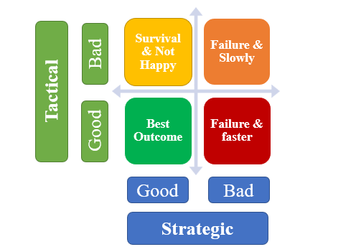

**Fig. 1.2** The asymmetry of strategic and tactical marketing.

1. **Definitions of Market Segmentation**

* Market segmentation is a decision-making tool for the marketing manager in the crucial task of selecting a target market for a given product.
* Market segmentation means cutting markets into slices.
* When an organisation decides not to use market segmentation, it is effectively choosing to pursue an undifferentiated market strategy.
* **Conceptually, market segmentation sits between the two extreme views: -**

1. All objects are unique and inviolable
2. The population is homogeneous
3. **The Benefits of Market Segmentation**

* Market segmentation has a number of benefits. At the most general level, market segmentation forces organisations to take stock of where they stand, and where they want to be in future.
* It forces organisations to reflect on what they are particularly good at compared to competitors, and make an effort to gain insights into what consumers want.
* Market segmentation has also been shown to be effective in sales management because it allows direct sales efforts to be targeted at groups of consumers rather than each consumer individually.

1. **The Costs of Market Segmentation**

* Implementing market segmentation requires a substantial investment by the organisation.
* A large number of people have to dedicate a substantial amount of time to conduct a thorough market segmentation analysis.
* If market segmentation is not implemented well, the entire exercise is a waste of resources.

**Market Segmentation Analysis**

1. The Layers of Market Segmentation Analysis
2. Approaches to Market Segmentation Analysis
3. Data Structure and Data-Driven Market Segmentation Approaches
4. Market Segmentation Analysis Step-by-Step
5. **The Layers of Market Segmentation Analysis**

* The process of grouping consumers into naturally existing or artificially created segments of consumers who share similar product preferences or characteristics.
* We use the term ***user*** to mean the user of the segmentation analysis: - The person or department in the organisation that will use the results from the market segmentation analysis to develop a marketing plan.
* Theoretically excellent market segmentation solution is meaningless unless users can convert such a solution into strategic marketing decisions and tactical marketing action.

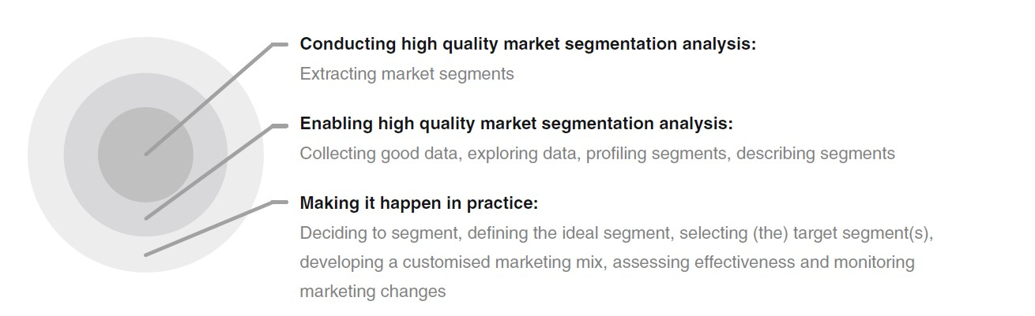

**Fig. 2.1** The layers of market segmentation analysis.

1. **Approaches to Market Segmentation Analysis**

* No one single approach is best when conducting market segmentation analysis.
* We present two systematics here: -

1. Based on Organisational Constraints (*Three approaches to market segmentation*)
2. Quantitative survey-based approach.
3. The creation of segments from existing consumer classification.
4. The creation of segments from existing consumer classification.

***These three approaches differ in how radical the resulting change is for the organisation.***

1. Based on the Choice of (the) Segmentation Variable(s)

* A more technical way of systematising segmentation approaches is to use as a basis the nature of consumer characteristics used to extract market segments.
* One single piece of information about consumers (one segmentation variable) is used.
* In other cases, multiple pieces of information (multiple segmentation variables) about consumers are important.

1. **Data Structure and Data-Driven Market Segmentation Approaches**

* When conducting data-driven market segmentation, data analysts and users of market segmentation solutions often assume that market segments naturally exist in the data.
* In real consumer data, naturally existing, distinct and well separated market segments rarely exist.
* distinguish three possible conceptual approaches to data-driven market segmentation: **natural**, **reproducible** or **constructive segmentation**

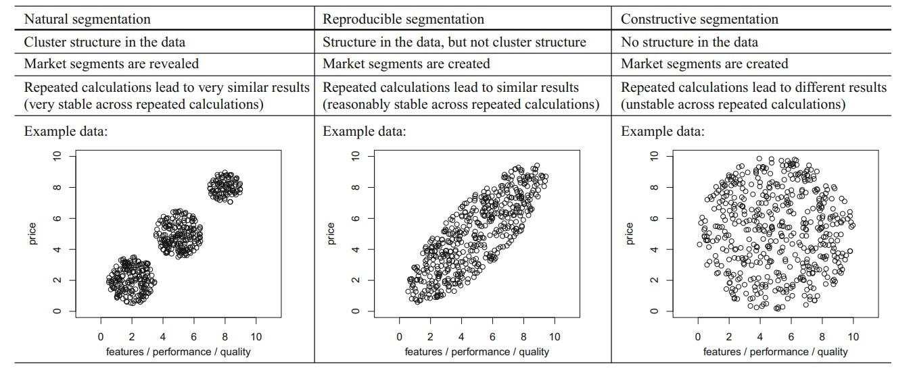

**Table 2.1** Data-driven market segmentation approaches based on data structure.

1. **Market Segmentation Analysis Step-by-Step**

* Ten-Step approach to market segmentation analysis.

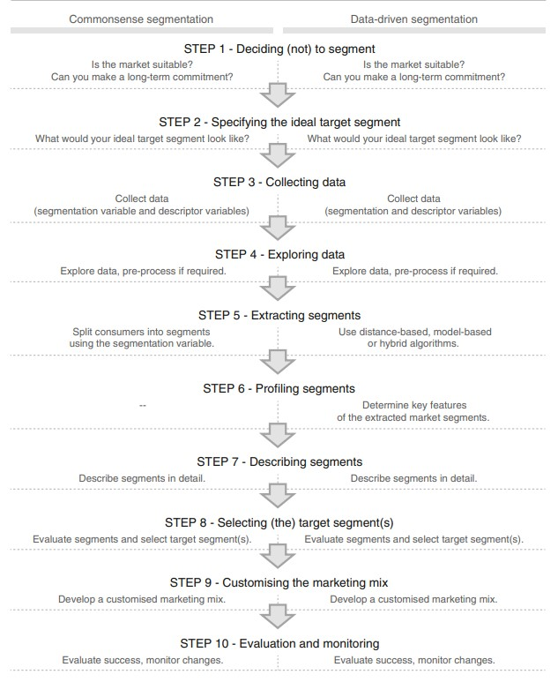

**Fig 2.2** Ten steps of market segmentation analysis

* The basic structure is the same for both commonsense and data-driven market segmentation.
* Although the ten steps of market segmentation analysis are the same for commonsense and data-driven segmentation. Different tasks need to be completed for each one of those approaches. Typically, data-driven segmentation requires additional decisions to be made.

**Step 1: Deciding (not) to Segment**

* **Implications of Committing to Market Segmentation**
* The key implication is that the organisation needs to commit to the segmentation strategy on the long term.
* Market segmentation is a marriage, not a date.
* Segmenting a market is not free. There are costs of performing the research, fielding surveys, and focus groups, designing multiple packages, and designing multiple advertisements and communication messages.
* Potentially required changes include the development of new products, the modification of existing products, changes in pricing and distribution channels used to sell the product, as well as all communications with the market.
* **Implementation Barriers**
* Barriers that can impede the successful roll-out of a market segmentation strategy.
* The first group of barriers relates to senior management. Lack of leadership, pro-active championing, commitment and involvement in the market segmentation process by senior leadership undermines the success of market segmentation.
* A second group of barriers relates to organisational culture.
* Another potential problem is lack of training.
* Another obstacle may be objective restrictions faced by the organisation, including lack of financial resources, or the inability to make the structural changes required.
* **Checklist**
* This first checklist includes not only tasks, but also a series of questions which, if not answered in the affirmative, serve as knock-out criteria.

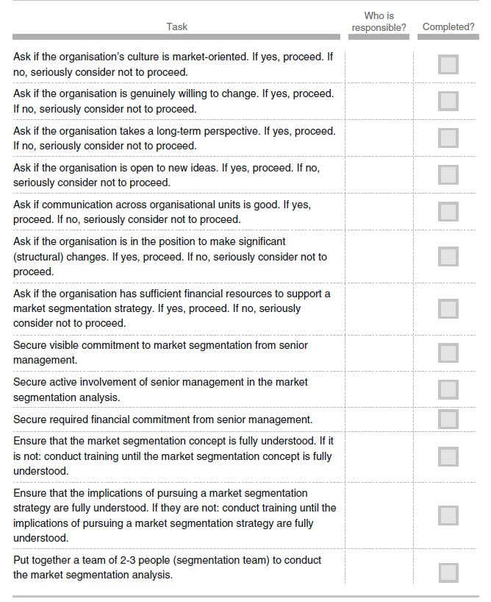

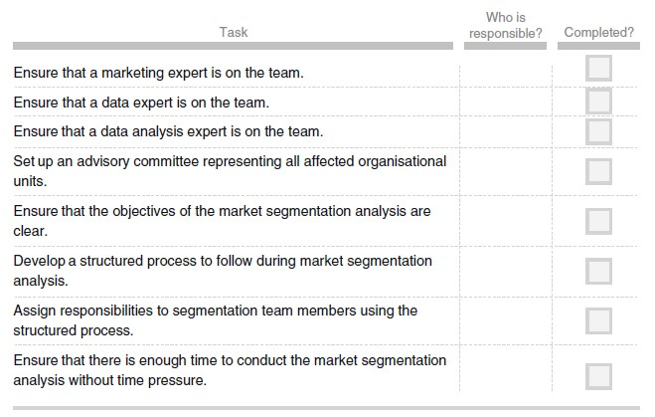

**Step 2: Specifying the Ideal Target Segment**

* **Segment Evaluation Criteria**
* One set of evaluation criteria can be referred to as knock-out criteria.
* The second set of evaluation criteria can be referred to as attractiveness criteria.
* **Knock-Out Criteria**
* Knock-out criteria are used to determine if market segments resulting from the market segmentation analysis qualify to be assessed using segment attractiveness criteria.
* The segment must be homogeneous
* The segment must be distinct
* The segment must be large enough
* The segment must be matching the strengths of the organisation
* Members of the segment must be identifiable
* The segment must be reachable
* **Attractiveness Criteria**
* A wide range of segment attractiveness criteria available to the segmentation team to consider when deciding which attractiveness criteria are most useful to their specific situation.
* The attractiveness across all criteria determines whether a market segment is selected as a target segment in Step 8 of market segmentation analysis.
* **Implementing a Structured Process**
* The most popular structured approach for evaluating market segments in view of selecting them as target markets is the use of a segment evaluation plot.
* Optimally, this task should be completed by a team of people. If a core team of two to three people is primarily in charge of market segmentation analysis, this team could propose an initial solution and report their choices to the advisory committee – which consists of representatives of all organisational units – for discussion and possible modification.
* **Checklist**

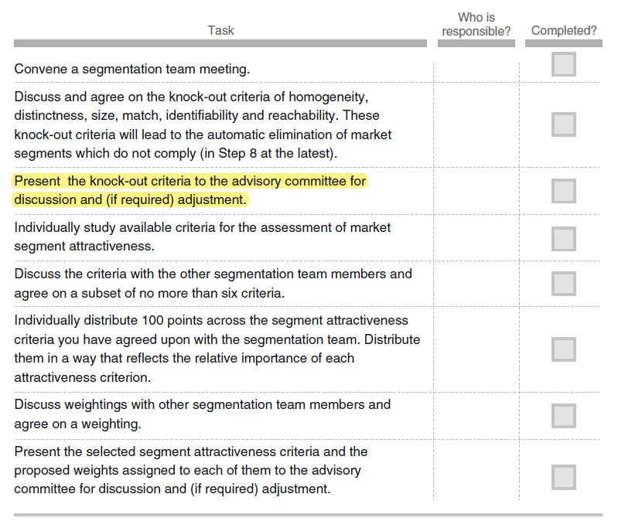

**Step 3: Collecting Data**

* **Segmentation Variables**
* Segmentation variable to refer to the variable in the empirical data used in commonsense segmentation to split the sample into market segments.
* In commonsense segmentation, the segmentation variable is typically one single characteristic of the consumers in the sample.
* The difference between commonsense and data-driven market segmentation is that data-driven market segmentation is based not on one, but on multiple segmentation variables.

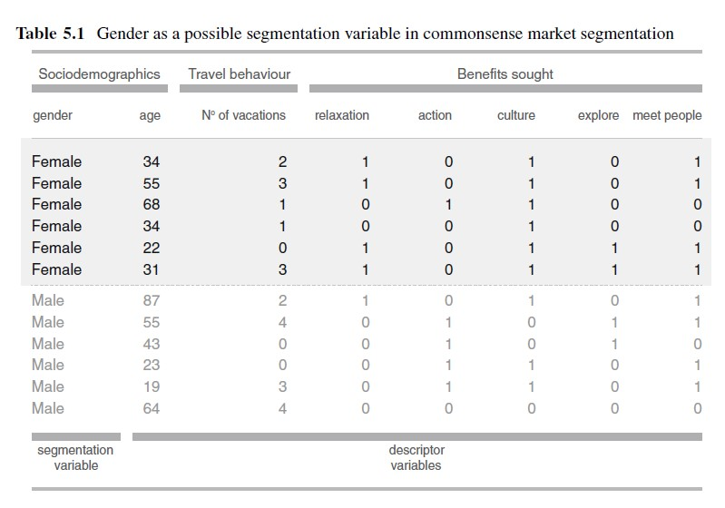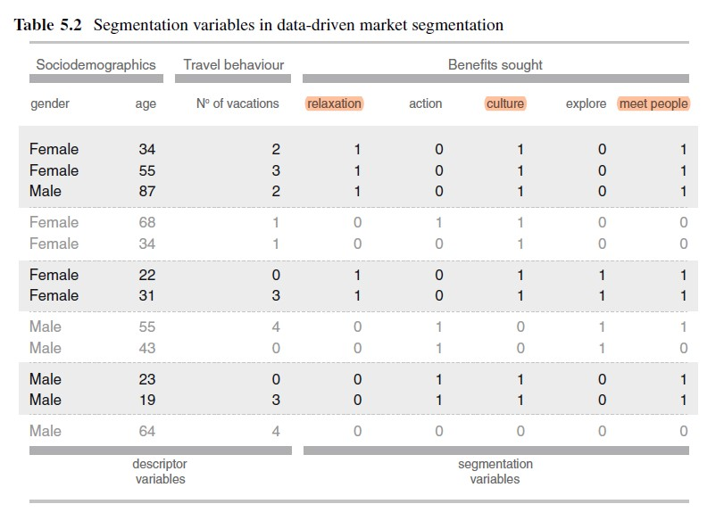

* **Segmentation Criteria**
* The organisation must make an important decision: it must choose which segmentation criterion to use.
* The term segmentation criterion relates to the nature of the information used for market segmentation.
* The decision which segmentation criterion to use cannot easily be outsourced to either a consultant or a data analyst because it requires prior knowledge about the market.
* The most common segmentation criteria are: -
* Geographic
* Sociodemographic
* Psychographic
* Behavioural
* **Data from Survey Studies**
* Survey data is cheap and easy to collect, making it a feasible approach for any organisation.
* But survey data – as opposed to data obtained from observing actual behaviour – can be contaminated by a wide range of biases.
* Such biases can, in turn, negatively affect the quality of solutions derived from market segmentation analysis. A few key aspects that need to be considered when using survey data are discussed below.
* Choice of Variables
* Response Options
* Response Styles
* Sample Size
* Data used in market segmentation analyses should: -
* Contain all necessary items;
* Contain no unnecessary items;
* Contain no correlated items;
* Contain high-quality responses;
* Be binary or metric;
* Be free of response styles;
* Include responses from a suitable sample given the aim of the segmentation study
* include a sufficient sample size given the number of segmentation variables (100 times the number of segmentation variables).
* **Data from Internal Sources**
* Increasingly organisations have access to substantial amounts of internal data that can be harvested for the purpose of market segmentation analysis.
* Typical examples are scanner data available to grocery stores, booking data available through airline loyalty programs, and online purchase data. The strength of such data lies in the fact that they represent actual behaviour of consumers, rather than statements of consumers about their behaviour or intentions.
* Another advantage is that such data are usually automatically generated and – if organisations are capable of storing data in a format that makes them easy to access – no extra effort is required to collect data.
* The danger of using internal data is that it may be systematically biased by over-representing existing customers.
* **Data from Experimental Studies**
* Another possible source of data that can form the basis of market segmentation analysis is experimental data.
* For example, they can be the result of tests how people respond to certain advertisements. The response to the advertisement could then be used as a segmentation criterion.
* **Checklist**

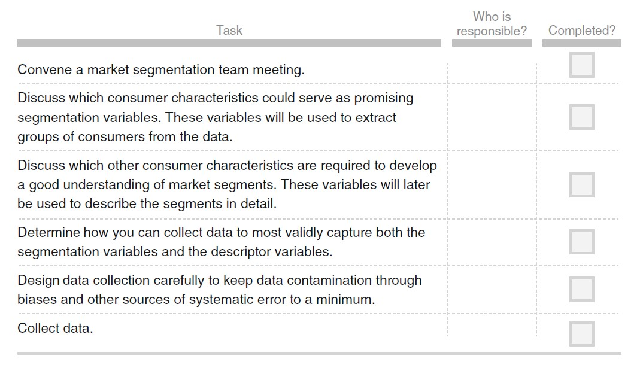

**Step 4: Exploring Data**

* **A First Glimpse at the Data**
* After data collection, exploratory data analysis cleans and – if necessary – pre-processes the data.
* This exploration stage also offers guidance on the most suitable algorithm for extracting meaningful market segments.
* Data exploration helps to: -
* Identify the measurement levels of the variables.
* Investigate the univariate distributions of each of the variables.
* Assess dependency structures between variables.
* In addition, data may need to be pre-processed and prepared so it can be used as input for different segmentation algorithms.
* Results from the data exploration stage provide insights into the suitability of different segmentation methods for extracting market segments.
* ***To read the data set into Python, we use the following command: -***

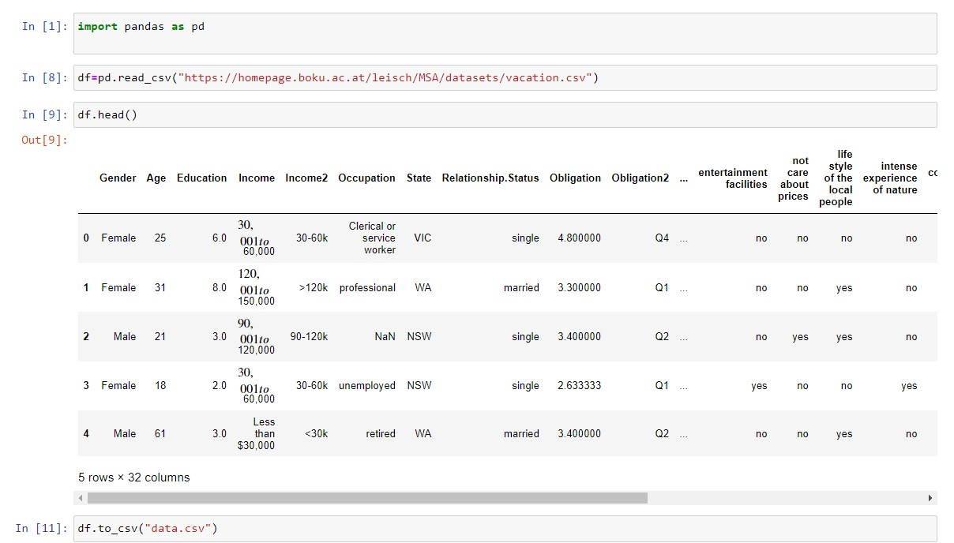

* After reading the data set into R, we store it in a data frame named ***df***. And then saved the data into ***data.csv*** file for future use.

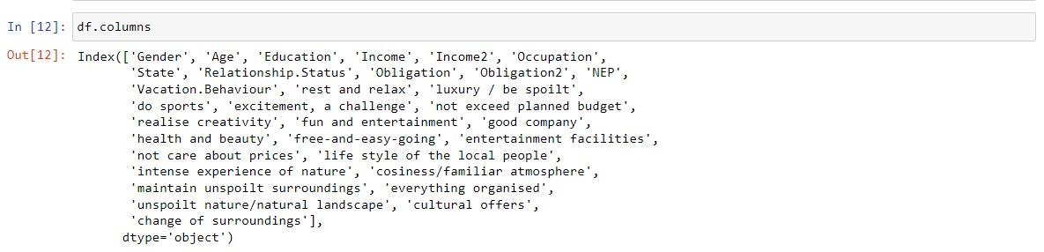

* All Column name of data sets.
* ***df.describe()*** generates a full summary of the data set.

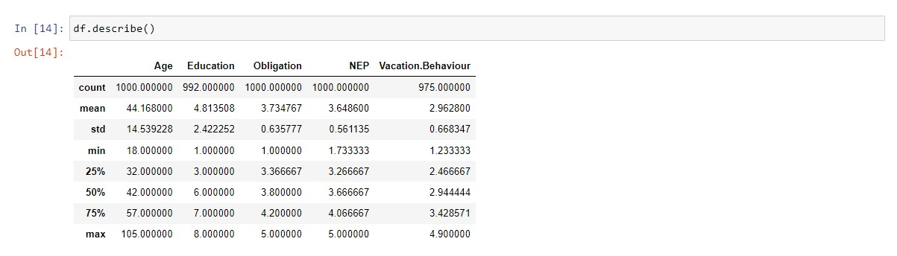

* Below we select only four columns to show Gender (column 1 of the data set), Age (column 2), Income (column 4), and Income2 (column 5).

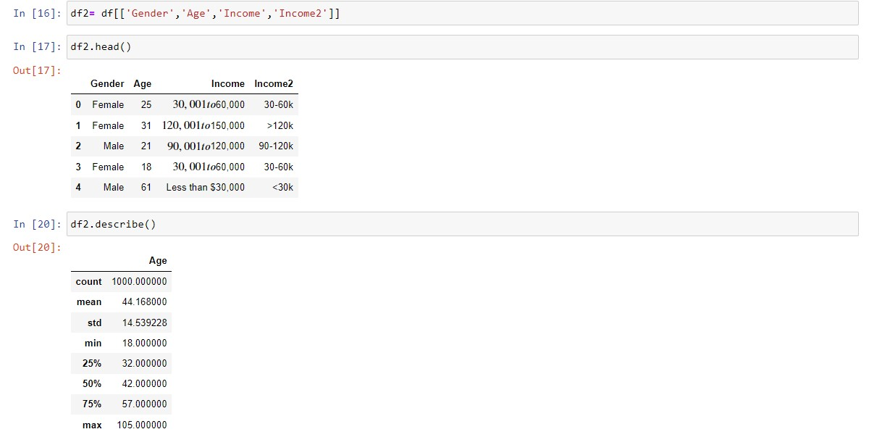

* **Data Cleaning**
* The first step before commencing data analysis is to clean the data. This includes checking if all values have been recorded correctly, and if consistent labels for the levels of categorical variables have been used.
* The summary of the variable Income2 reveals that the categories are not sorted in order.
* The possible categories of these variables are called levels. By default, levels of factors are sorted alphabetically. This explains the counter-intuitive ordering of the income variable in the Australian travel motives data set.
* One way to achieve this is to copy the column to a helper variable inc2, store its levels in lev, find the correct re-ordering of the levels, and then convert the variable into an ordinal variable.

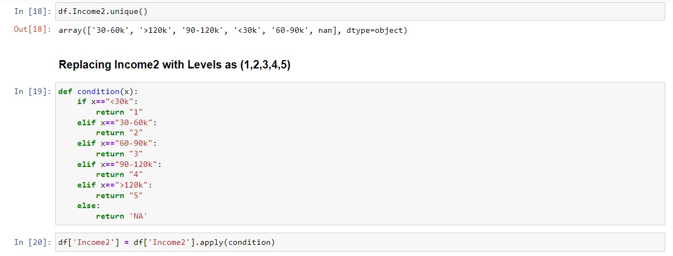

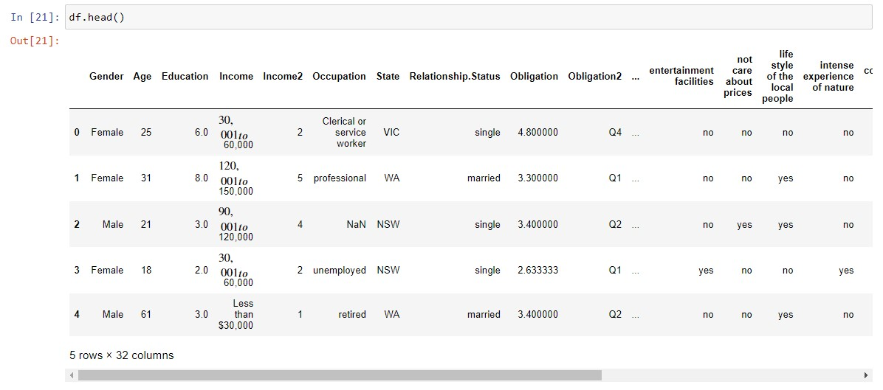

* **Descriptive Analysis**
* Being familiar with the data avoids misinterpretation of results from complex analyses. Descriptive numeric and graphic representations provide insights into the data.
* Statistical software packages offer a wide variety of tools for descriptive analysis.
* In Python, we obtain a numeric summary of the data with command ***describe()***.

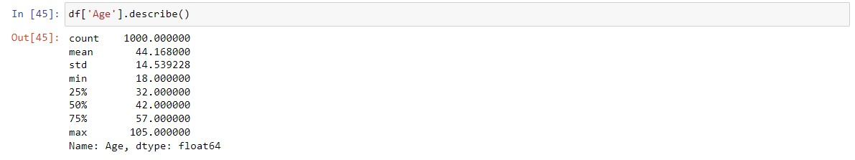

* This command returns the range, the quartiles, and the mean for numeric variables.
* Helpful graphical methods for numeric data are histograms, boxplots and scatter plots.
* **Histograms**
* Histograms visualise the distribution of numeric variables. They show how often observations within a certain value range occur. Histograms reveal if the distribution of a variable is unimodal and symmetric or skewed. To obtain a histogram, we first need to create categories of values. We call this binning.
* The bins must cover the entire range of observations, and must be adjacent to one another. Usually, they are of equal length.
* We plot the bin range on the x-axis, and the frequency of observations in each bin on the y-axis.
* We can construct a histogram for variable AGE using.

For Type = Percentage

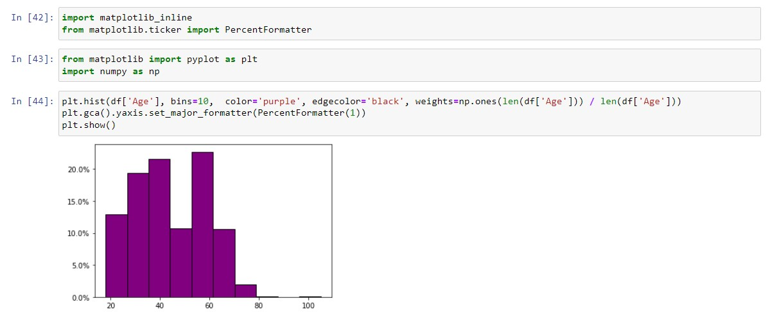

For Type =Density

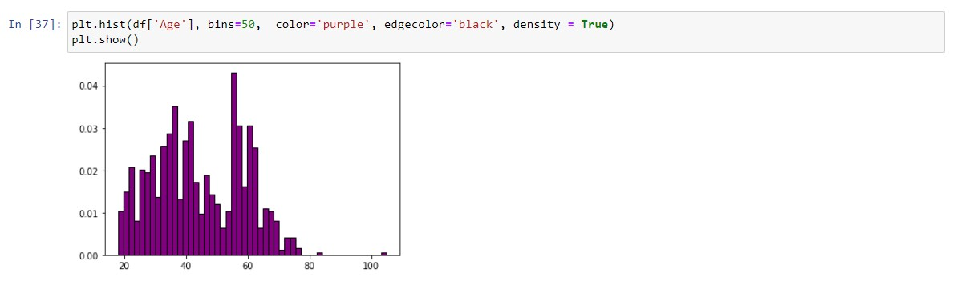**Histograms of tourists’ age in the Australian travel motives data set**

* **Boxplot**
* The simplest version of a boxplot compresses a data set into minimum, first quartile, median, third quartile and maximum. These five numbers are referred to as the five number summary.

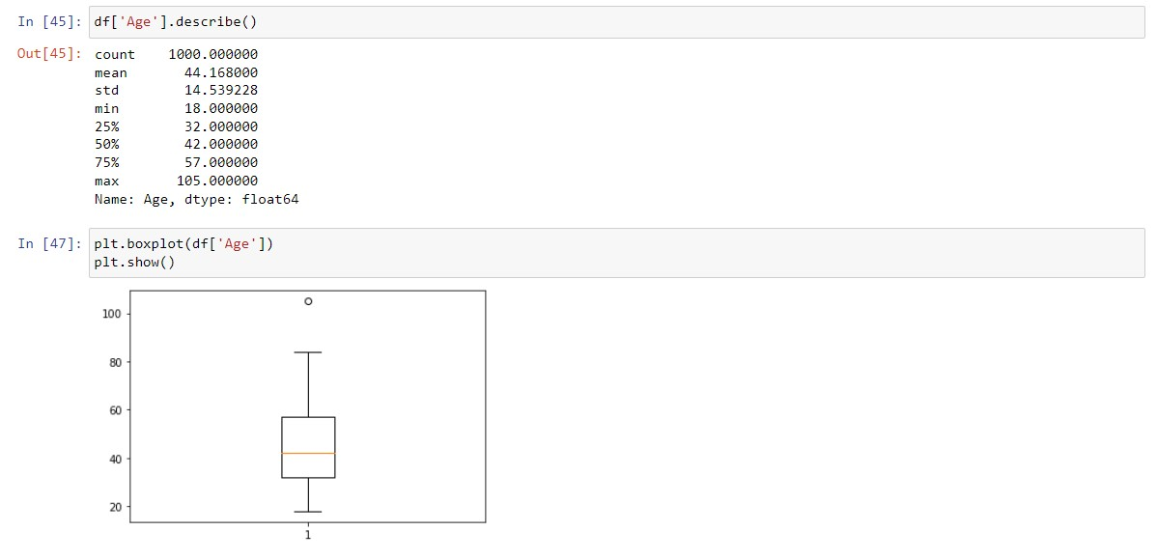

Horizontal Box plot

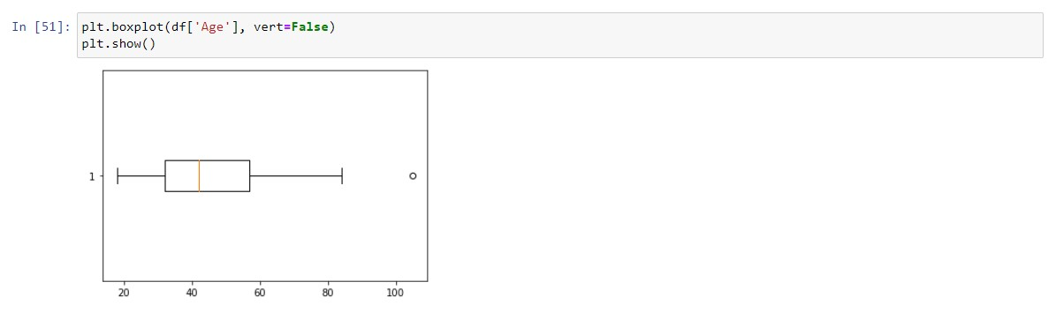**Box-and-whisker plot of tourists’ age in the Australian travel motives data set**

* ***Vert = False*** indicates that the box is horizontally aligned, otherwise it would be rotated by 90◦.
* A simple box-and-whisker plot provides insight into several distributional properties of the sample assuming unimodality. For the Australian travel motives data set, the boxplot shows that the data is right skewed with respect to age because the median is not in the middle of the box but located more to the left.
* A symmetric distribution would have the median located in the middle of the inner box.
* **Checklist**

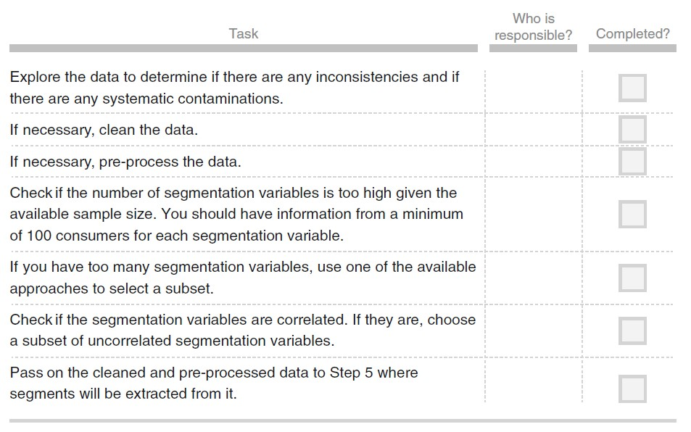

[Github Link](https://github.com/AkshayAthelits/Fenny-Lab_Projects2)